**Updating Software OTA on A CubeSat LEO Path 2**

By Terry Osborne ZL2BAC

Following the original paper in the AMSAT-NA Symposium proceedings, See Notes and [1] and the summary by Philip Sharp (ZL1PSH) in “Break In” November/December 2022 (see [2] and Note 2), I analysed the ground track of a typical cubeSAT in SSO with the intention of finding out how much the uploading time could be reduced by using stations in the Southern Hemisphere. I found two possible tracks that could reduce the upload time to around 1 orbit. The results for a path over New Zealand are described in “Break In” January/February 2022 [3]. This paper describes a second path over the South Pole, Americas, Arctic, East Asia and Western Australia.

The AMSAT-NA paper gives 2MByte for the upload file size. It also divides this file into 1024 segments which gives a segment length of 2,048 Bytes.

If we now create the Segment Frame using the Bytes defined in the AMSAT-NA paper, see table 1.

|  |  |  |
| --- | --- | --- |
| Field | Type | Remarks |
| MsgID | 2-byte value | This message has value 3 |
| SatId | 16-byte value | Unique for the satellite |
| UpdateNo | 4-byte value | Update number |
| SegNo | 4-byte value | Segment number sent |
| SegLen | 4-byte value | Length of segment sent |
| Segment | 2,048-bytes | The actual segment |
| Sign | 256-byte value | Digital signature |

Table 1

We now have a total of 2334 Bytes.

Now multiply this by 8 to convert Bytes to bits for transmission.

So we have 18,672 bits.

Now add 50% for FEC overheads to get 28,008 bits.

If we now upload this frame at 9600 bps we get 28,008/9600 = 2.918 seconds. We should double this time to account for time to establish the link and to confirm that the segment has been received correctly. So roughly 6 seconds for the segment upload time.

Now multiply these times by 1024 (6x1024= 6144 Seconds) or 102.4 minutes.

Assuming FO-118 (CAS-5A [4]) is in a typical CubeSat orbit, height 543 KM, inclination 97.53 degrees and a period of 95.575 minutes we can use the FO-118 Keplerian elements to calculate how long it would take to load an “image”.

For a station in the mid latitudes the average access time per day at elevations above 10 degrees is 21.4 minutes. See Figure 1 and Notes 3.

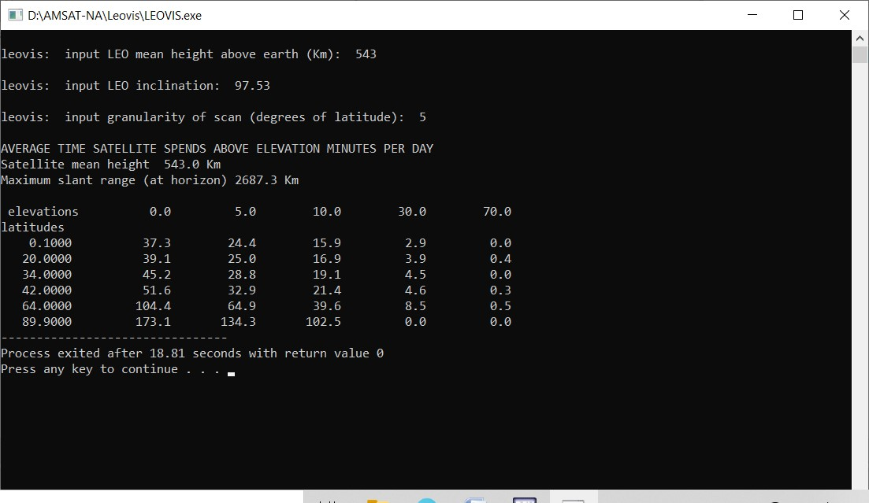

Figure 1.

Thus it would take 4.78 days for a single station to upload an image.

I used Orbitron [5] to analyse the orbits for FO-118 and see whether any patterns could be found to reduce the upload time. Orbitron has the ability to run simulations and will show the ground track of the satellite. See Figure 2 (New York 1) for a pass over New York.

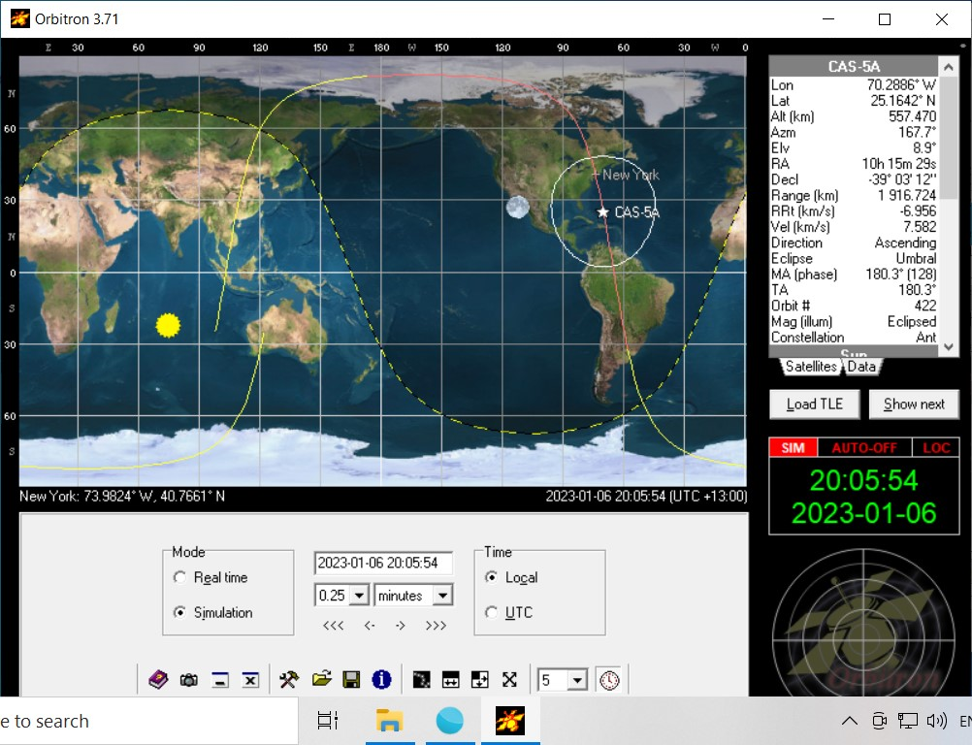Figure 2 (New York 1).

If we go back along the ground track, the ground track runs from Western Australia, to Antarctica, South America, North America, Alaska, East Asia and back to Western Australia.

The elevation data on the top right of Figure 2 shows an elevation of 8.9 degrees which would be the lower elevation limit for reliable uploads.

The Orbitron plot for a station in Caracas (Venezuela) Figure 3 (Caracas 2) shows an elevation of 10.3 degrees which would be an excellent had over point for the New York station to begin uploading.

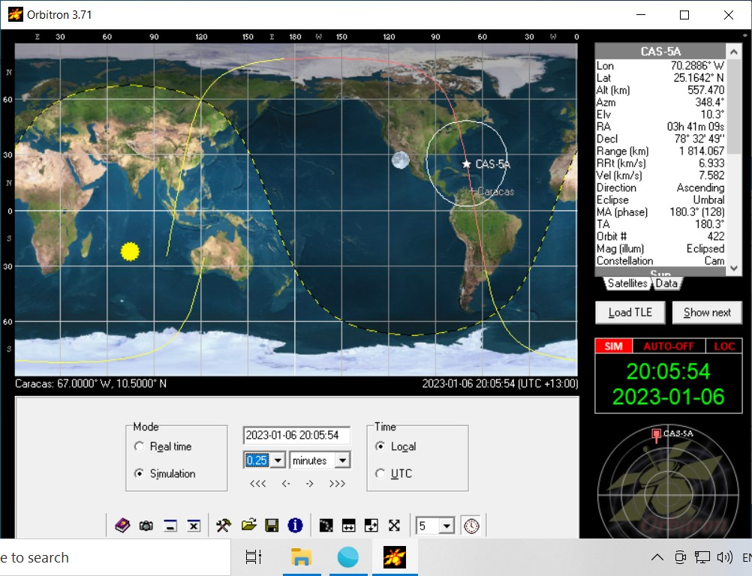

Figure 3 (Caracas 2).

Heading North from New York, the footprint reaches up into the Arctic, see: Figure 4 (New York 2)

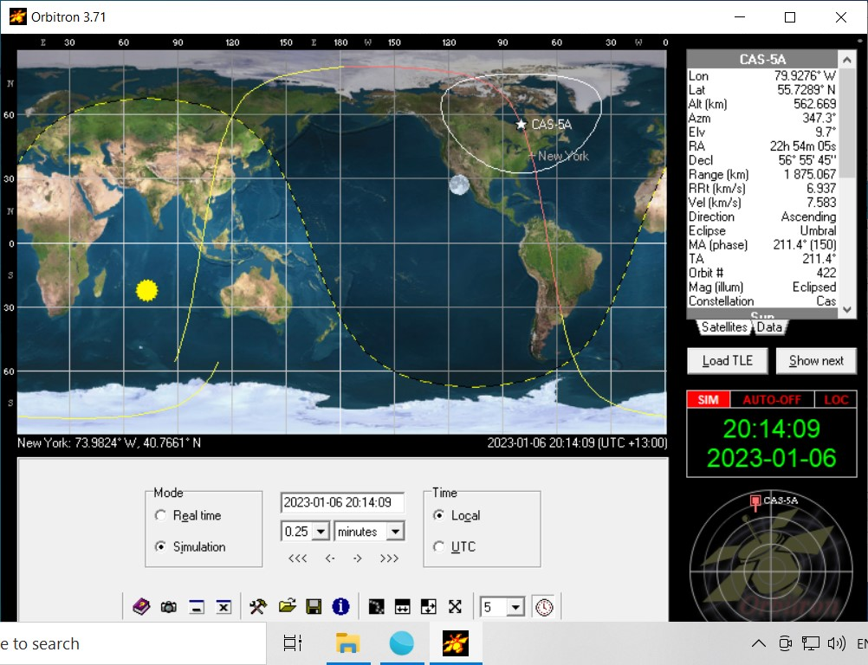

Figure 4 (New York 2).

where it joins Barrow, Figure 5 (Barrow 1).

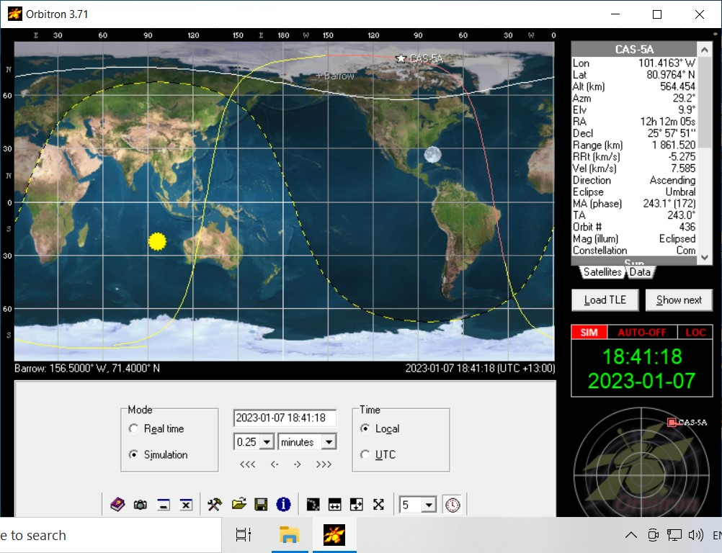

Figure 5 (Barrow 1)

Similarly it is possible to select a chain of stations along the satellite ground track where the footprints for about 10 degrees elevation join up.

By utilising stations in Perth (Western Australia), South Pole, Buenos Aries, Caracas (Venezuela), New York, Barrow (Alaska), Tokyo, Singapore and back to Perth it is possible to have a continuous upload for most of an orbit or about 70 minutes. So an upload can be completed in little more than 1 orbit.

The Orbitron plots for all these stations can be viewed here [6].

Another similar line of stations through Africa, Europe, Barrow, Hawaii, Fiji, New Zealand and the South Pole would produce a similar result.

So by selecting ground stations along a North /South path and a careful choice of orbit an upload can be completed in around 110 minutes.

Notes 1: The AMSAT-NA Symposium papers are only available to members of AMSAT-NA.

You can join AMSAT-NA at https://launch.amsat.org/Membership. The benefits of membership are shown here: <https://launch.amsat.org/Member-Benefits>.

Notes 2: “Break In” is the “Journal of the New Zealand Association of Radio Transmitters”.

New Zealand’s equivalent of QST.

Notes 3: Figure 1 was produced with an old DOS program, “Leovis” by Duncan Courtenay N5BF. Many years ago, Courtney Duncan N5BF wrote a simple program to predict the time spent at various elevation angles. This program is available in the AMSAT archives as “Leovis” see: https://www.amsat.org/amsat/ftp/software/PC/tracking/ . This is an old DOS program and would not run on my Windows 10 box. Duncan was kind enough to include the source code in the distribution and I was able to re-compile and run it.

References: [1] AMSAT_ Proceedings_2022.pdf “OTA Software Update for LEO satellites by

Heimir Thor Sverrisson, W1ANT/TF3ANT”

[2] “Updating software on a software defined CubeSat LEO satellite” Break In November/December 2022 page 12.

[3] “Updating software on a software defined CubeSat LEO satellite: Part2” Break In January/February 2023 page 10.

[4] CAS-5A-Amateur-Radio-Satellite-Users-Manual-V1.0 which can be downloaded from here: https://ukamsat.files.wordpress.com/2022/12/cas-5a-amateur-radio-satellite-users-manual-v1.0.pdf

[5] Orbitron Satellite tracking program, http://www.stoff.pl/.

[6] https://github.com/TerryOz/Updating-Software-OTA-on-a-cubeSAT-in-LEO